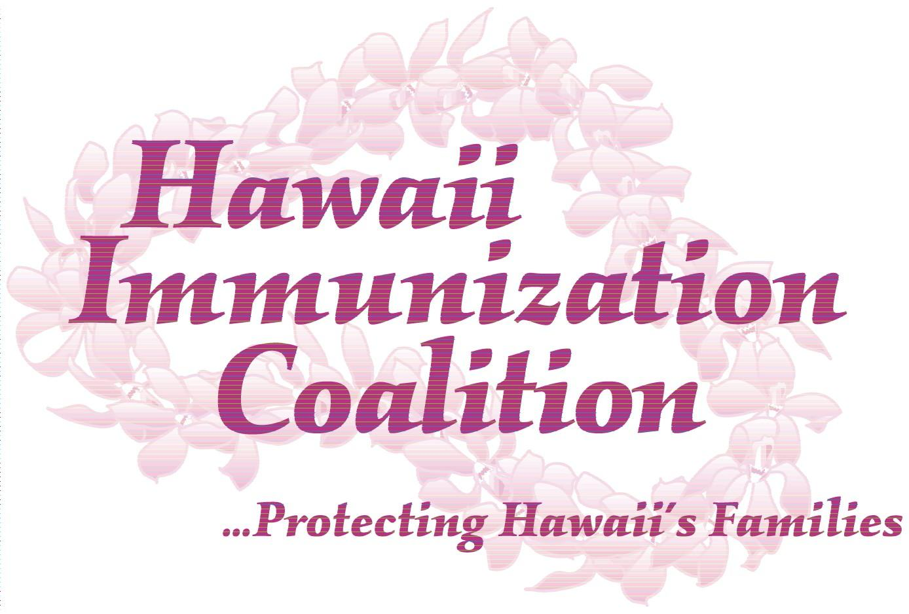
Become an HIC Partner Agency!

Hawaii Immunization Coalition (HIC) is a 501(C)3 non-profit organization that works with all immunization providers in Hawaii in support of full immunization across the lifespan. We welcome your involvement as a Partner Agency.

By completing the form below, your agency acknowledges and supports our local efforts with no additional obligation. We will add your agency’s name and website link to the Partner Agency list on our website, www.immunizehawaii.org.
This list may be used to demonstrate community buy-in for future funding opportunities and advocacy efforts, but it will not otherwise be used without permission.

Agency
Contact  Name |  |  |  |  |  |  |  | Date
Address |  |  |  |  |  |  |  | City
State |  | Zip Code |  | Phone
Email |  |  |  |  | AgencyWebsite

Please email this completed form to hicimmunizehawaii@gmail.com.

